
ACTIVE LEARNING TEMPLATE: Growth and Development

STUDENT NAME

DEVELOPMENTAL STAGE PRE-SCHOOL REVIEW MODULE CHAPTER

EXPECTED GROWTH AND DEVELOPMENT
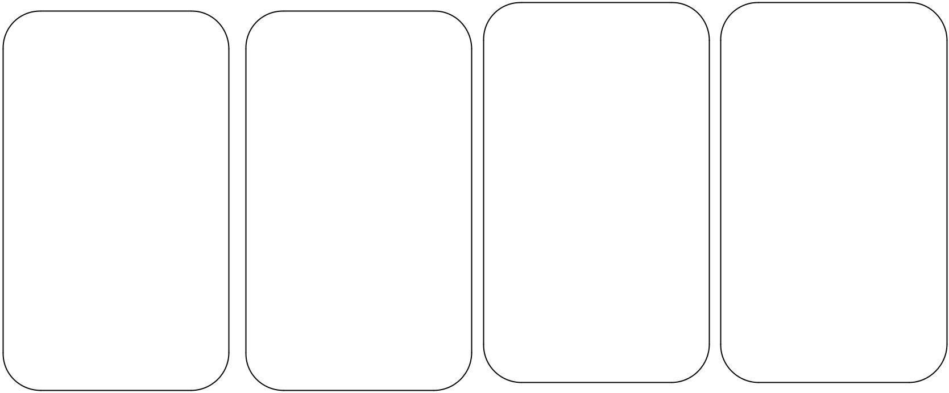

Physical
Development

The child has becomes strong and began to look Lithe and long (Malina, 2012).

Cognitive
Development

The child’s reasoning and thinking ability has improved a lot. The child has learnt colors, letters and counting some numbers. He knows most familiar faces and strangers.
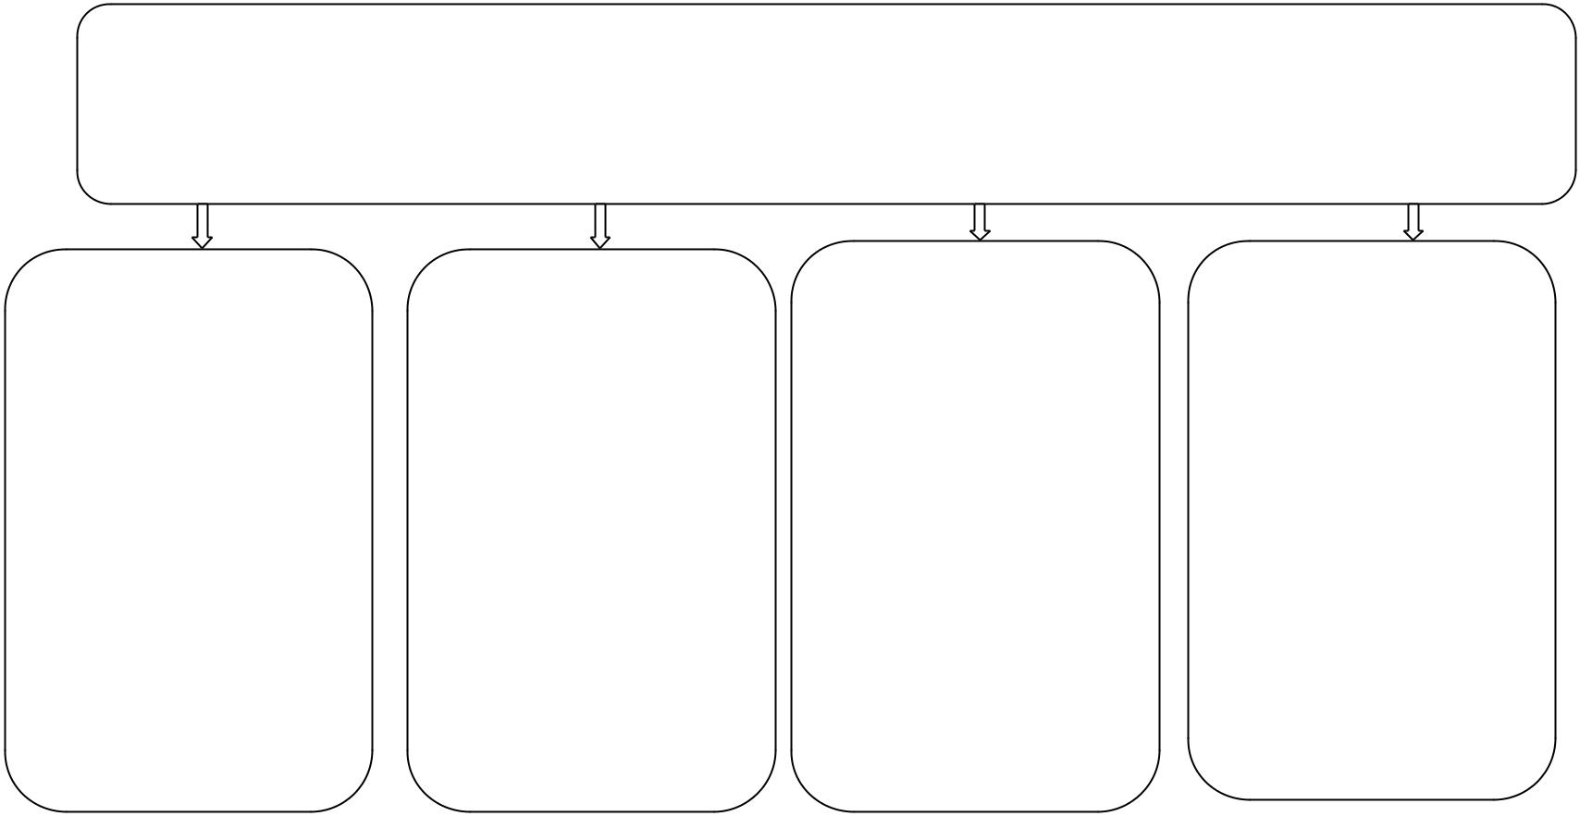

Psychological
Development

Between the ages of 2 and 5, children gradually learn how to manage their feelings. By age 5, friends become important (Onis, 2000).

Age- Appropriate Activities

The activities that encourage the children to learn should be encouraged at this age Matching colors playing rice games and sorting and building blocks of similar colors.

Health promotion

The child should be checked by physicians for persisting characters such as thumb sucking, biting and stuttering or slurred speech. Those are some of the indicators that may show abnormal growth.

 | Immunizations |  |  |  | Health Screening
 | The most important |  |  |  | Screening must be
 | vaccine for preschool |  |  |  | done routinely for
 | child includes polio, |  |  |  | visual and hearing
 | diphtheria, viceria, |  |  |  | impairment. Dental
 | rotavirus and NMR (Onis, 2000). |  |  |  | screening should be
 |  |  |  |  | done together with
 |  |  |  |  | other appropriate
 |  |  |  |  | screening which in
 |  |  |  |  | clued physical and
 |  |  |  |  | mental health.

Nutrition

The child at this age requires balance diet for better growth and development. The child should serve regularly and different foods should be tried.

Injury Prevention

Preschool age is the most destructive and perilous period of a child’s life. The child should be kept away from dangerous equipment and blunt objects. The child play time should be carefully monitored.

ACTIVE LEARNING TEMPLATES THERAPEUTIC PROCEDURE A5

